**Hotel Management System**

Group Members:

Amina Waheed (114)

Haroon Naeem (072)

Eman Nawaz (119)

 s **use case diagram of Hotel Management System**

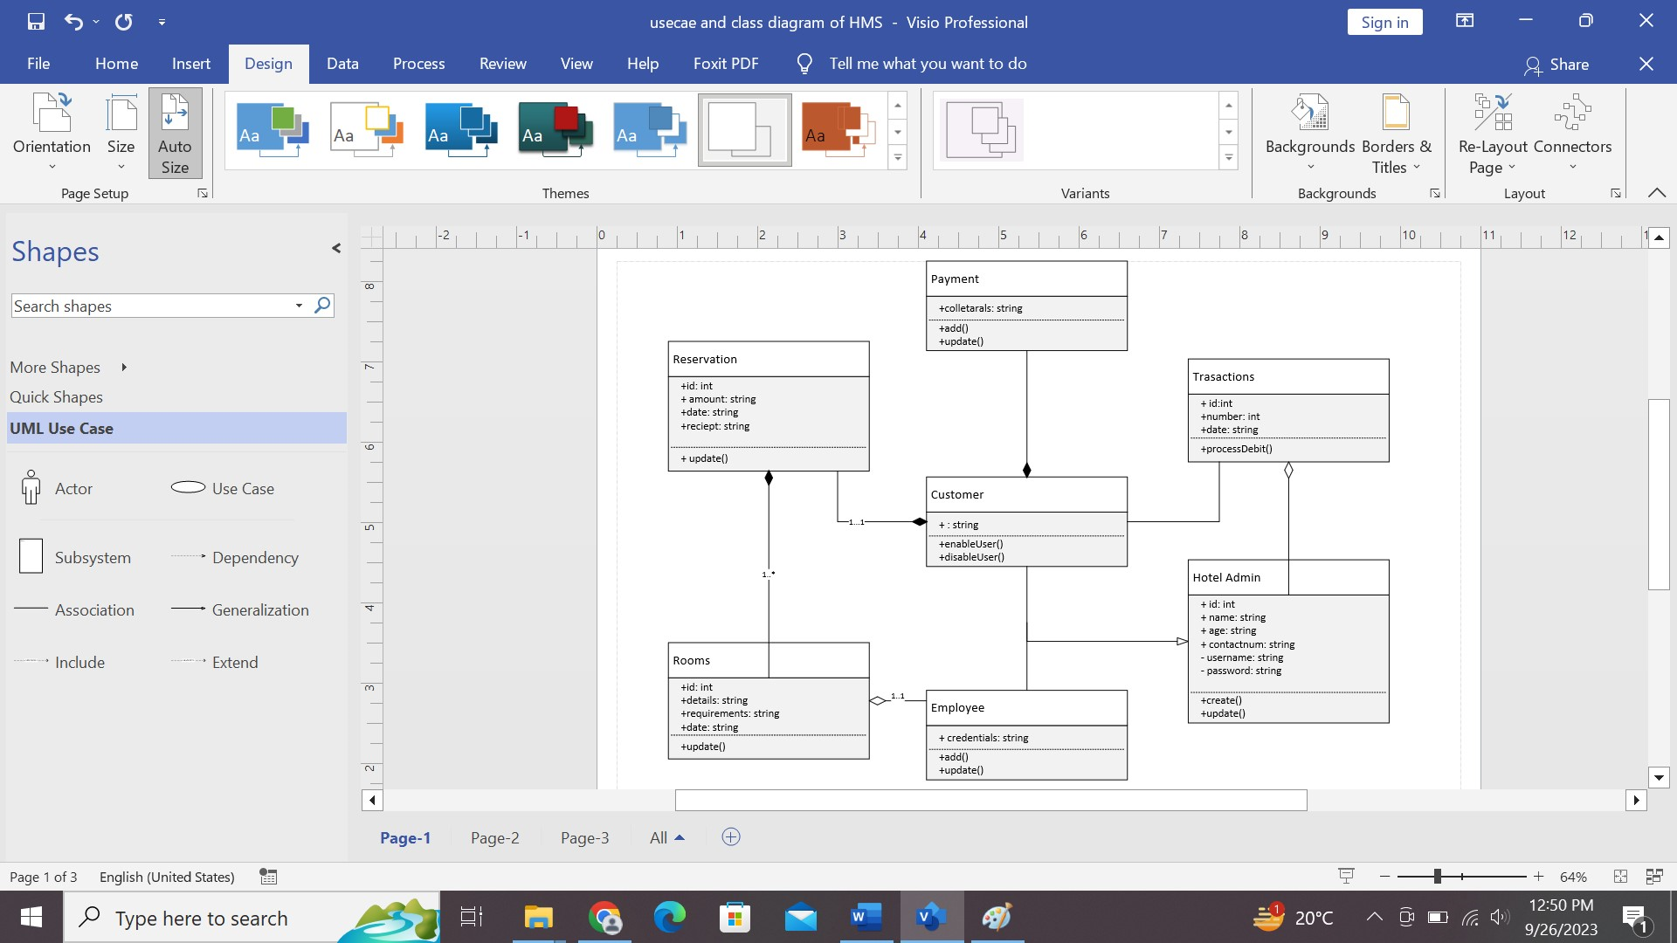

**Class diagram of Hotel Management System**